Dear Prospective Sponsor,
Ovation Dance Companies have begun a new and exciting year! This is the studio’s 4th year in our community, and we are continuing to build the tradition of excellence at Ovation Dance. The Ovation Dance Companies remains a positive program for students in which they achieve many life lessons working as team members representing the studio and serving the community. Our organization is based on the principles of dedication, self-discipline, confidence, humility, and team work. The Ovation Dance Company experience will contribute to helping these young students to grow in qualities that extend far beyond dance. The sincere hope is upon graduation the students continue to contribute to the communities in which they become involved.
We are currently raising funds to support the Companies for the 2018-2019 season. Contributions last year allowed us to host Standing Ovation- (Fundraiser for the Festival of Giving), put on 6 memorable and exciting Showcases and to enter several competitions where we won the awards such as Best Performance, Best Choreography & Best Originality.
We are currently seeking business and individual sponsors to help enable us to participate in Conventions, purchase costumes, supplies, and fund our team-building events required for the Company to maintain and exceed the level of expertise they reached last year. All proceeds from these sponsorships will go directly to support the Ovation Dance Companies and towards Ovation Dance Scholarships.
All sponsors will be recognized throughout the year at our various events (please refer to attached form). We will also strongly encourage our Ovation families to in turn support our Sponsors with their business. **Ovation Dance is not a non-profit corporation and sponsors may write-off their sponsorship as an advertising expense.
These various sponsorship levels allow individuals and companies to support the Ovation Dance Company at the level in which they are comfortable. Your support will allow the students the opportunity to grow as both a team and an individual. We appreciate any level of support that you can give the members of the Ovation Dance Company. Please contact Kiah Carpenter at kiah@ovationpac.com or 208-572-5523 for more information or to participate in the program.

Thank you,
Kiah Carpenter
Director, Ovation Dance
208-572-5523 | ovationdanceid@gmail.com| www.ovationpac.com
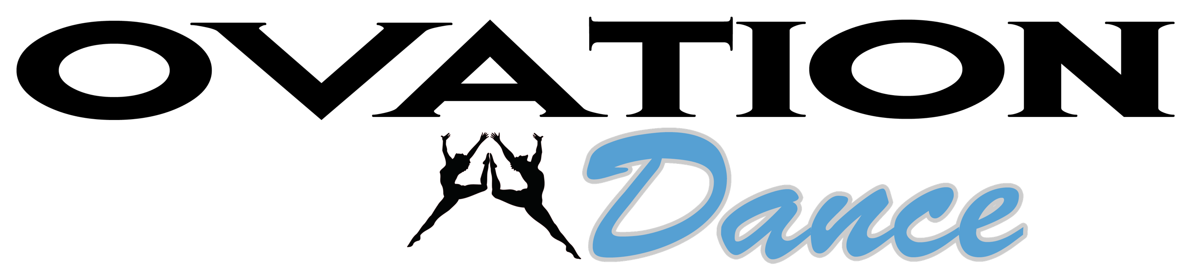

Ovation Dance Company Sponsorship Levels
FAMILY $25
- Recognition on the Sponsor Page on Ovation’s Website
- Recognition in the Winter/Spring Showcase Programs
BRONZE $50
- All Previous Plus+
- Social Media Shout out on Our Facebook and Instagram Pages
- Business Card Printed in our Winter/Spring Showcase Programs

SILVER $100
- All Previous Plus+
- Choice of Business card or 1/4-page ad in the Winter/Spring Showcase Programs
GOLD $150
- All Previous Plus+
- Choice of Business card, ¼-page ad, or 1/2-page ad in the Winter/Spring Showcase Programs
- 2 tickets to the Winter/Spring Showcase

PLATINUM $200+
- All Previous Plus+
- Choice of Business card, 1/4-page ad, 1/2-page ad or Full-page ad in the Winter/Spring Showcase Programs
- Recognition on the Sponsor Page on Ovation’s Website with link to your Website. (must provide Vector file)
- Sponsor Advertising Display in the Lobby at our Spring Recital
Please fill out the attached form and mail to Ovation Dance with your sponsorship or Sponsor Us Online at https://goo.gl/EZfgBb: *Ovation Dance is not a non-profit corporation and sponsors may write-off their sponsorship as an advertising expense.

Please Make Checks Payable to:
OVATION DANCE
Mail Forms and Donations to:
Ovation Dance c/o Kiah Carpenter
1280 Monaco St,
Twin Falls, ID 83301
Ovation Sponsorship Print Deadlines
Advertisement in Ovation Winter Showcase Program: Print materials for the Winter Showcase Program must be received by November 16, 2018.
Advertisement in Ovation Spring Showcase Program: Print materials for the Spring Showcase Program must be received by April 19, 2019.
Your donation to this program is very much appreciated and will go a long way in sustaining the growth and success of the students involved.
Thank you so much for your sponsorship!
Sponsorship Level: _________________ Amount Included: $__________________
Company/Sponsor name: ____________________________________________________
Address: ___________________________________________________________________
Phone Number: _____________________________________________________________
Email: _____________________________________________________________________
Website: _____________________________________________________________
Would you like your Spring Show tickets?
Donated back to the Company__________ Will Call__________
Who would you like to sponsor? Entire Company_____ Scholarship Program ______
Company Member (Name) _____________________________________________________

